Sri Lanka Institute of Advanced Technology Education.

(SLIATE)

**INDIVIDUAL PROJECT**

**Report – 2023/24**

**Food inventory management system**



For the partial fulfilment of Individual Project in First Year First

Semester of Higher National Diploma in Information Technology in

Advanced Technological Institute of Thangalle Sri Lanka.

**H.P.D.dilshan kumara. Supervisor: K.D.A.fernando**

**TAN/IT/2023/F/0062**

**Acknowledgment.**

I would like to extend my heartfelt gratitude to **K.D.A.fernando** for the invaluable guidance, support, and encouragement provided throughout the development of the **Food Inventory Management System**. Your expertise and constructive feedback have been vital in shaping the direction and success of this project.

I deeply appreciate the time and effort you dedicated to reviewing my work and offering suggestions that improved both the technical and functional aspects of the system. Your patience, advice, and encouragement have been a source of inspiration during challenging moments.

This project would not have been possible without your mentorship, and I am truly grateful for your unwavering support. Thank you for believing in my potential and helping me bring this project to completion.

**Table of Contents**

01) Introduction of the project 5

2) Requirements. 6

2.1 Functional Requirements 6

2.2 Non-Functional Requirements 6

2.3 Resource Requirements 7

3. System Design. 8

3.1. ER Diagram 8

3.1.1. Entities and Attributes: 8

3.1.2. Relationships: 8

3.2. Data Flow Diagram (DFD level 1) 10

3.2.2. External Entities: 10

3.3.3. Processes: 11

3.3.4. Data Stores: 11

3.4. DFD Level 1 Description: 11

3.4.1. Manage Food Items: 11

3.4.2. Manage Orders: 11

3.4.3. Manage Inventory: 12

3.4.4. Manage Supplier: 12

3.4.5. Relationships: 12

5. Database Structure 13

5.1. Tables 13

• Login form details Table 14

Design view 15

Category Table: 16

Design view 17

Supplier Table: 18

Design view 19

Food Items Table 20

Design view 21

Order Table: 22

Design view 23

Inventory Table 24

Design view 25

5.2. Forms 26

Food Item Form: 26

Design view 27

Inventory Form: 27

Design view 28

Login Form: 29

Design view 30

Login button code 30

Navigation Form: 31

Design view 32

Order Form: 32

Design view 33

Supplier form: 34

Design view 34

5.3. Queries 35

Category easy check 35

Design view 36

• food item easy check 37

Design view 38

Inventory and order 2 in one 39

Design view 40

Order and delivery information’s 40

5.4. Reports 41

Category 41

Food Item 42

Inventory 42

Order 43

Relationships for Food Inventory Management System 43

Supplier 44

5.5. Relationships 44

46

Summary of How These Components Work Together: 46

6) Resources 47

7) Challenges and Solutions 48

8) Conclusion 49

9) Project schedule/plan 50

**10) References** 51

# 01) Introduction of the project

**Food Inventory Management System** is a software application designed to efficiently track, manage, and organize food inventory within restaurants, grocery stores, food production units, or any business dealing with perishable goods. Its primary purpose is to ensure that food supplies are adequately stocked, minimize waste, and optimize inventory levels.

This system helps businesses monitor stock levels, track expiration dates, and automate reordering processes. By doing so, it reduces the chances of overstocking or running out of essential items, which can lead to financial loss or customer dissatisfaction.

Additionally, a Food Inventory Management System provides real-time data analytics, which enables users to make informed decisions, identify trends, and improve overall operational efficiency. It simplifies inventory tracking, saves time, and helps businesses maintain a high standard of food quality and safety.

# 2) Requirements.

## ****2.1 Functional Requirements****

1. **Database Tables**:
   * Tables to store food item details, stock quantities, expiration dates, and supplier information.
2. **Forms**:
   * Forms for entering and updating food inventory data, supplier details, and stock levels.
3. **Reporting Tools**:
   * Ability to generate detailed reports, such as:
     + Inventory status (current stock levels, expired items).
     + Purchase history and restocking needs.
     + Wastage and spoilage analysis.
4. **Data Entry Validation**:
   * Ensure proper data validation for food inventory entries (e.g., product names, stock quantities, expiration dates).

## ****2.2 Non-Functional Requirements****

1. **Usability**:
   * The system will be user-friendly, with an intuitive interface that requires minimal training for staff.
2. **Security**:
   * Data security will be ensured through user authentication and encryption for sensitive information, such as supplier details and stock data.
3. **Performance**:
   * The system will efficiently handle large volumes of inventory data without delays in retrieving or updating information.
4. **Scalability**:
   * The database will be designed to accommodate future growth, including expanding food item data and supplier records, without affecting system performance.

## ****2.3 Resource Requirements****

1. **Hardware**:
   * **Processor**: Intel Core i3 or higher
   * **RAM**: 3 GB or more
   * **Storage**: 700 MB of free disk space
   * **Monitor**: Standard display with 1024x768 resolution or higher.
2. **Software**:
   * **Operating System**: Microsoft Windows 7/10/11
   * **Database**: Microsoft Access 2016 or later
   * **Additional Tools**: .NET Framework (if additional features are needed)
3. **Human Resources**:
   * **Database Developer**: To design, implement, and maintain the system.
   * **Inventory Managers**: To input and manage food inventory data, track stock levels, and handle reordering.

# 3. System Design.

## 3.1. ER Diagram

### 3.1.1. Entities and Attributes:

1. **Category**
   * Category ID (Primary Key)
   * Category Name
2. **Food Item**
   * Food ID (Primary Key)
   * Category ID (Foreign Key referencing Category)
   * Name
   * Quantity
   * Purchase Date
   * Expiration Date
3. **Inventory**
   * Inventory ID (Primary Key)
   * Food ID (Foreign Key referencing Food Item)
   * Stock In
   * Stock Out
   * Date Recorded
4. **Supplier**
   * Supplier ID (Primary Key)
   * Supplier Name
   * Address
   * Email
   * Contact Number
5. **Order**
   * Order ID (Primary Key)
   * Food ID (Foreign Key referencing Food Item)
   * Supplier ID (Foreign Key referencing Supplier)
   * Order Date
   * Total Cost

### 3.1.2. Relationships:

* **Category to Food Item**: One-to-Many (A category can have multiple food items, but each food item belongs to only one category).
* **Food Item to Inventory**: One-to-Many (A food item can have many inventory records, but each inventory record corresponds to only one food item).
* **Food Item to Order**: Many-to-Many (A food item can appear in many orders, and each order can contain multiple food items). This requires a junction table if more detailed data is needed.
* **Supplier to Order**: One-to-Many (A supplier can supply many food items through multiple orders, but each order is associated with one supplier).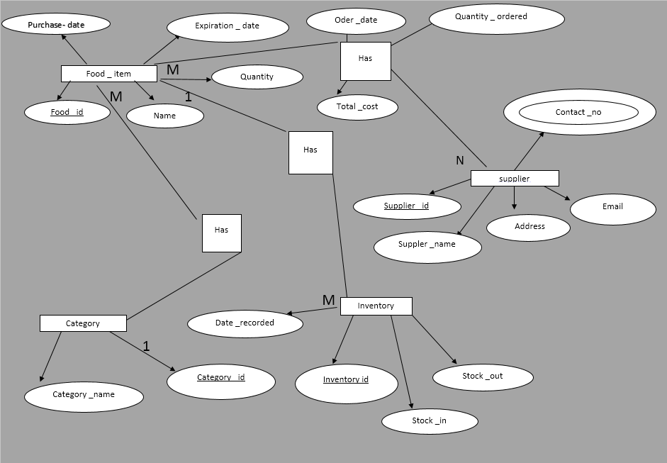

## 3.2. Data Flow Diagram (DFD level 1)

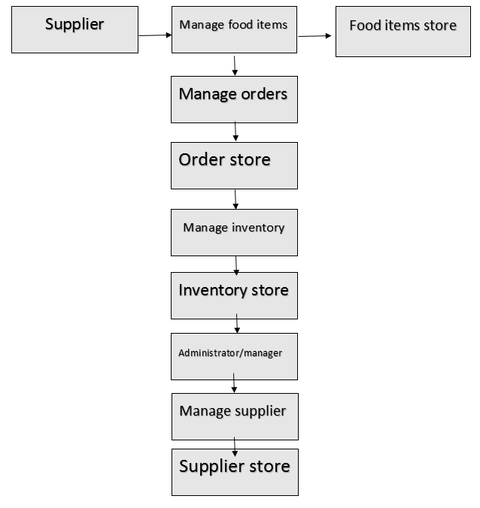

### 3.2.2. External Entities:

1. **Supplier**: External entity that provides food items.
2. **Customer**: External entity that orders food items.
3. **Administrator/Manager**: Internal entity that manages the system.

### 3.3.3. Processes:

1. **Manage Inventory**: Handles the processes for tracking and updating inventory data.
2. **Manage Orders**: Manages food orders placed by customers and links them with suppliers.
3. **Manage Food Items**: Manages food item details including adding, updating, and maintaining food inventory.
4. **Manage Supplier**: Handles the details related to suppliers.

### 3.3.4. Data Stores:

1. **Food Items Store**: Stores information about food items (ID, name, quantity, purchase and expiration dates).
2. **Supplier Store**: Stores supplier details (ID, name, contact, and address).
3. **Order Store**: Stores details about customer orders (order ID, food ID, quantity, total cost).
4. **Inventory Store**: Stores inventory records (inventory ID, stock in, stock out, and date recorded).

## 3.4. DFD Level 1 Description:

### 3.4.1. ****Manage Food Items****:

* Input: Data about food items from the **Administrator/Manager**.
* Output: Updated food item details to the **Food Items Store**.
* Data Flow:
  + **Administrator/Manager** inputs food item details (ID, name, category, quantity, etc.).
  + Food item details are updated in the **Food Items Store**.

### 3.4.2. ****Manage Orders****:

* Input: Order details from **Customer**.
* Output: Updates to **Order Store**.
* Data Flow:
  + **Customer** places an order with food items and the quantity.
  + The order is processed and recorded in the **Order Store**.
  + Once the order is confirmed, it may trigger the update to the **Inventory Store** (to reflect stock in/out).

### 3.4.3. ****Manage Inventory****:

* Input: Stock updates from **Administrator/Manager** or order adjustments (stock out).
* Output: Updated inventory details to **Inventory Store**.
* Data Flow:
  + **Administrator/Manager** provides stock updates (in/out) or the system adjusts inventory when an order is processed.
  + The **Inventory Store** is updated with stock-in and stock-out transactions.

### 3.4.4. ****Manage Supplier****:

* Input: Supplier details from **Administrator/Manager**.
* Output: Supplier information is stored in **Supplier Store**.
* Data Flow:
  + **Administrator/Manager** enters or updates supplier details (contact information, address).
  + Supplier details are updated in the **Supplier Store**.

### 3.4.5. Relationships:

* **Supplier** provides food items to the system, which is recorded in the **Food Items Store**.
* **Customer** places orders, which affect the **Inventory Store** (as stock is updated when food is ordered).
* The **Administrator/Manager** interacts with all data stores, maintaining and updating food item details, inventory, orders, and supplier data.

# 5. Database Structure

5.1. Tables

5.2. Forms

5.3. Queries

5.4. Reports

5.5. Relationships

## 5.1. ****Tables****

Tables are the core components of a database that store the actual data. In this system, several tables would be used to store information about suppliers, food items, orders, inventory, etc. Each table has columns (attributes) and rows (records), where each row represents a single instance of data. For example:

* Login form details Table**:**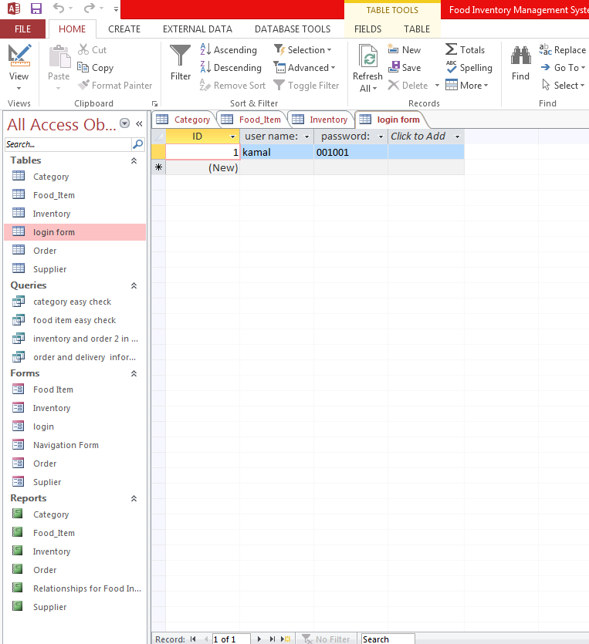

Design view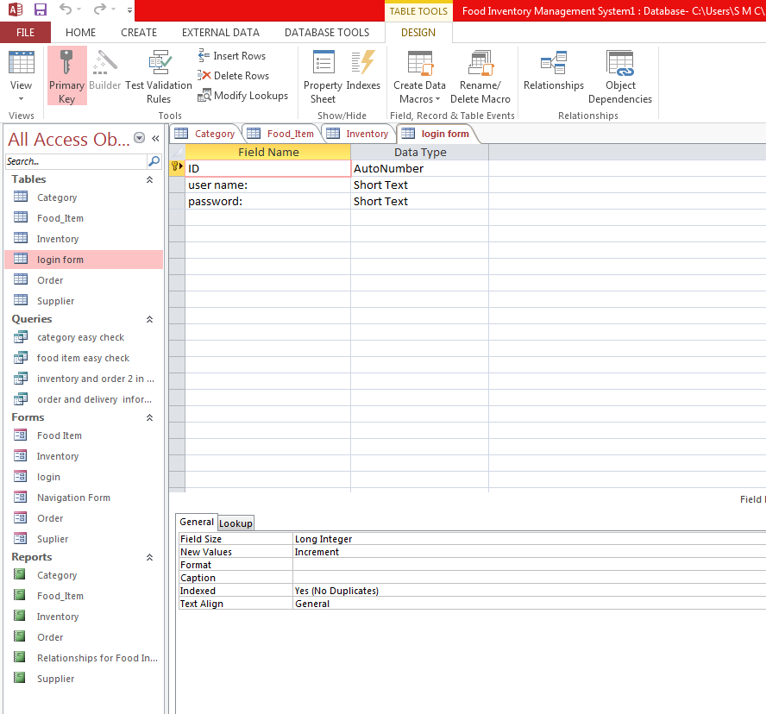

### Category Table:

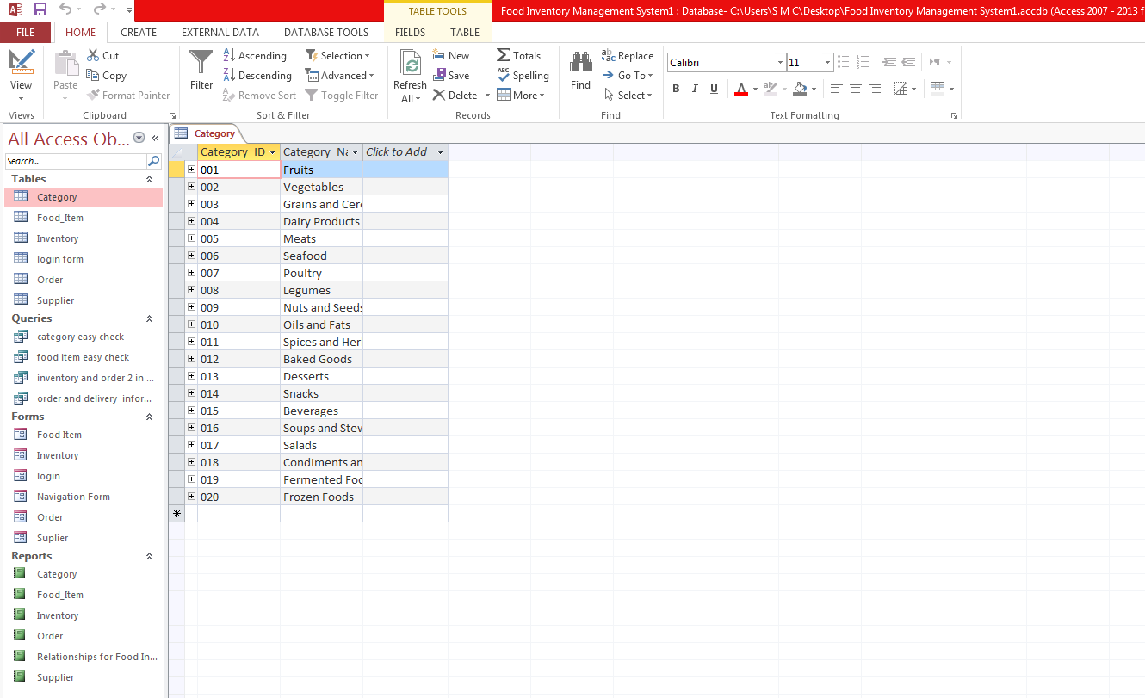

### Design view

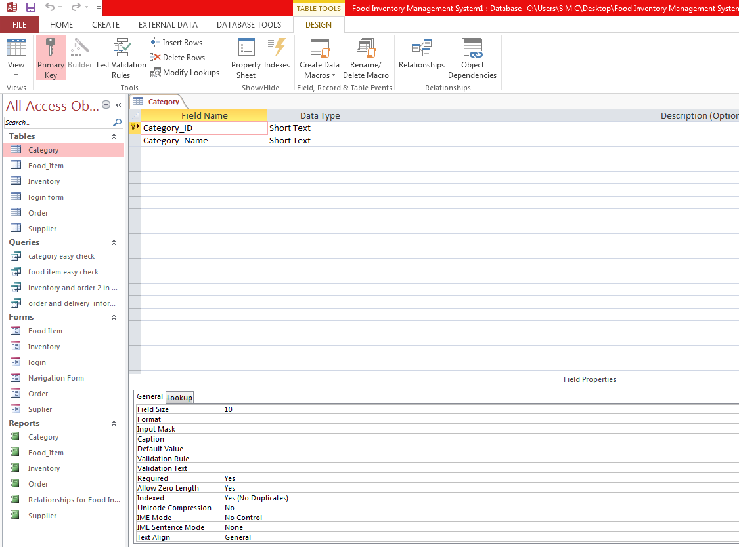

### **Supplier Table**:

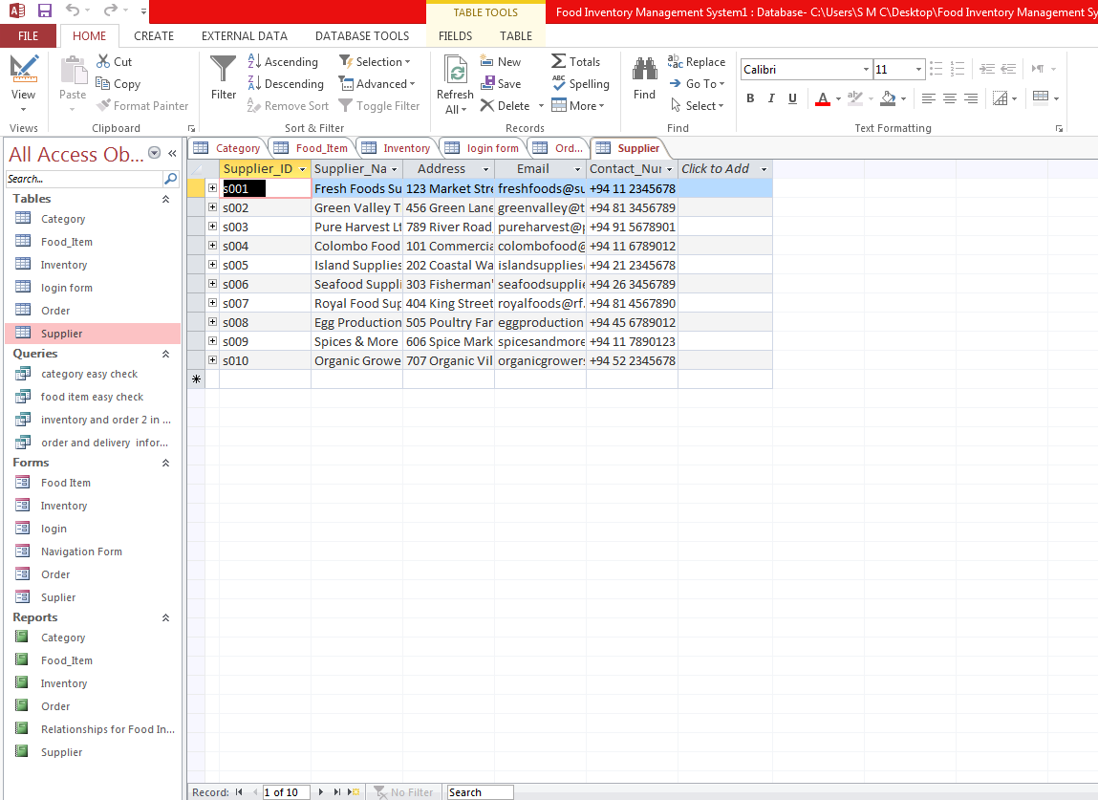

### Design view

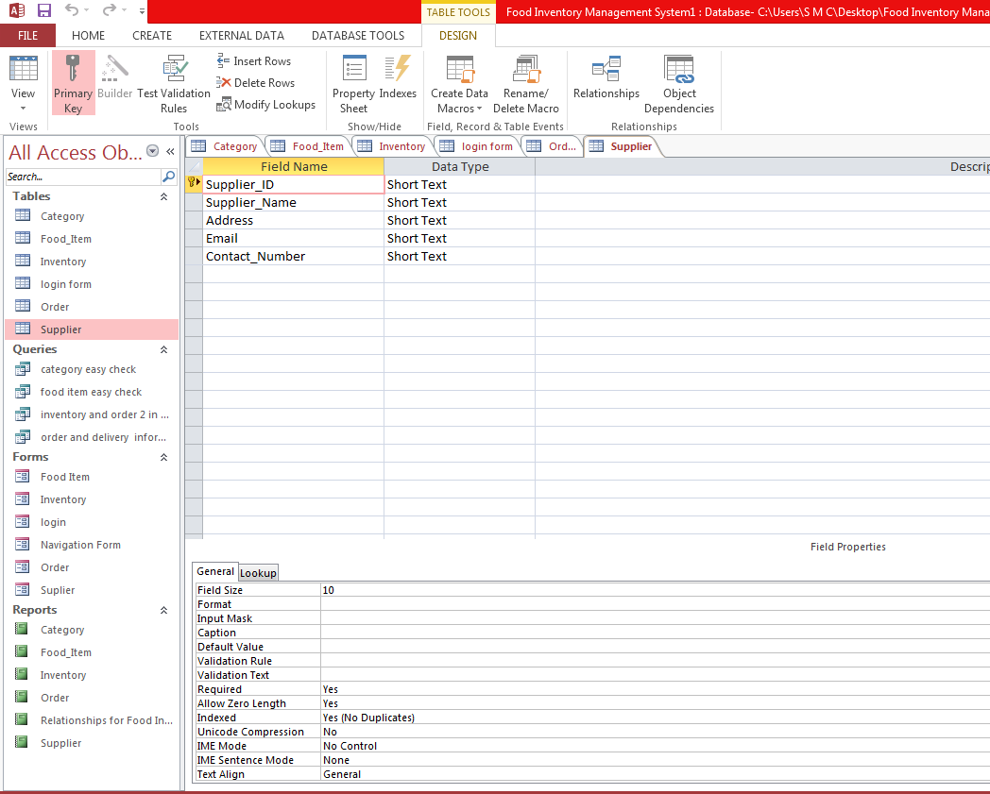

### **Food Items Table**

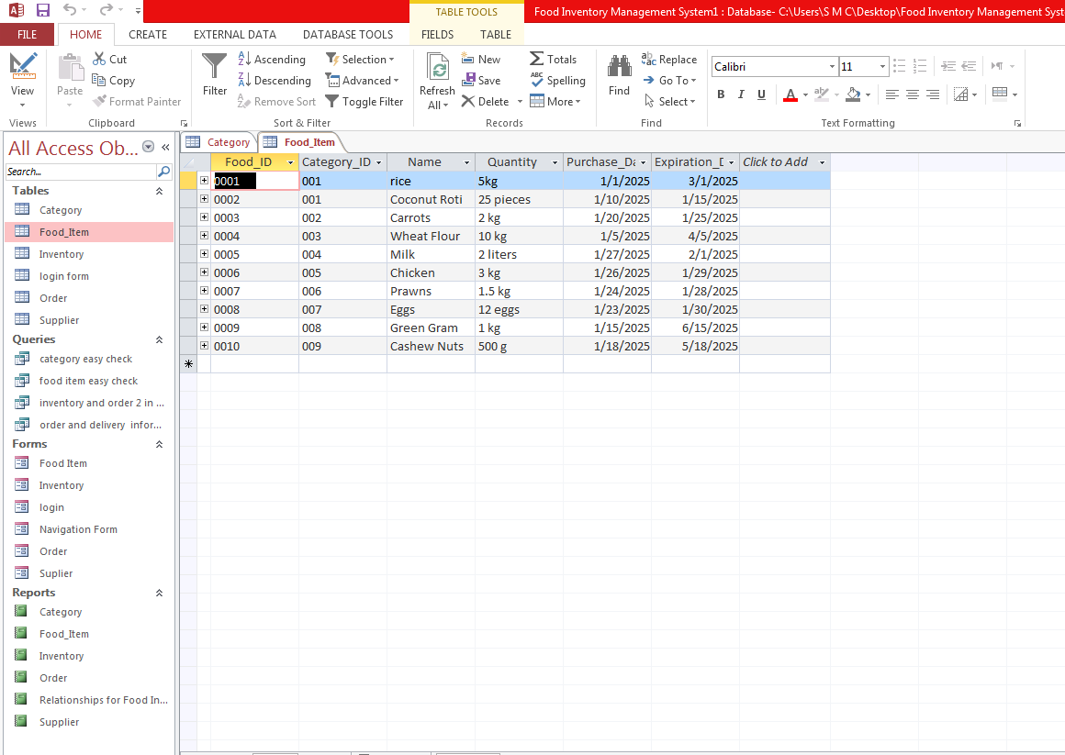

### Design view

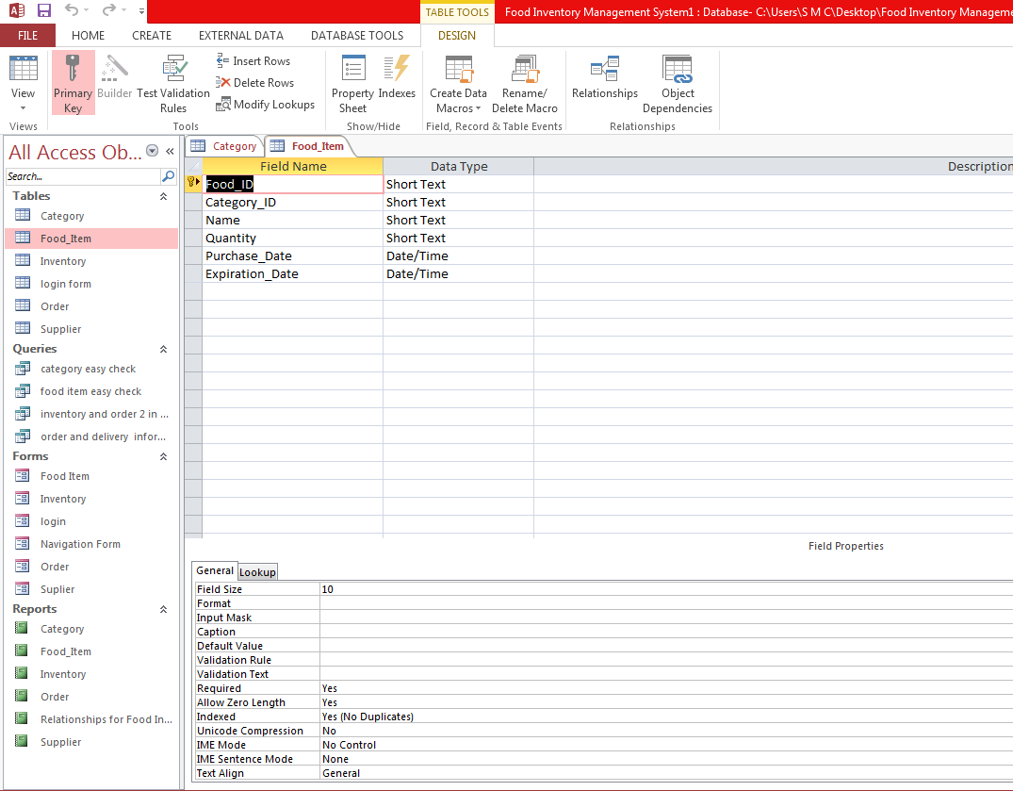

### **Order Table**:

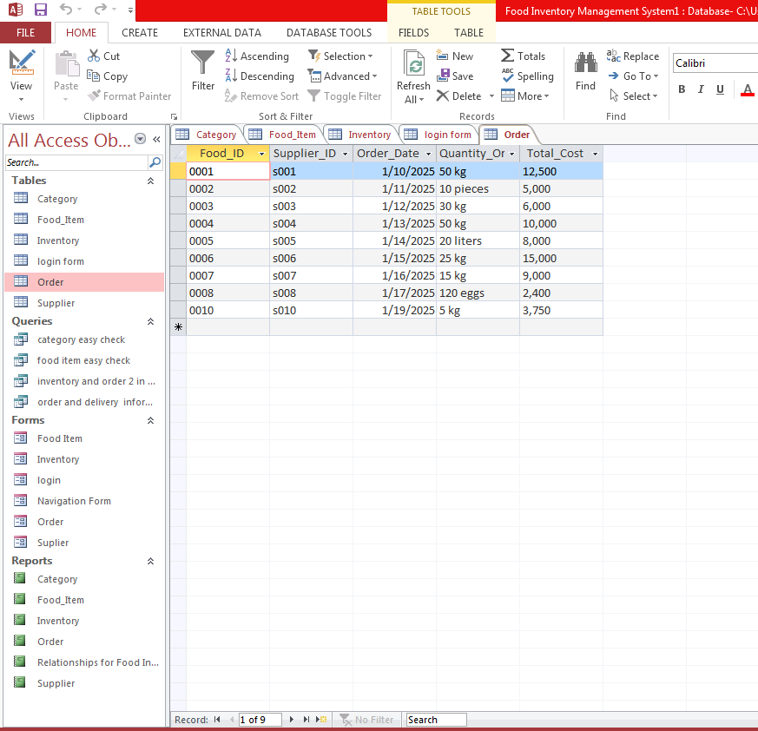

### Design view

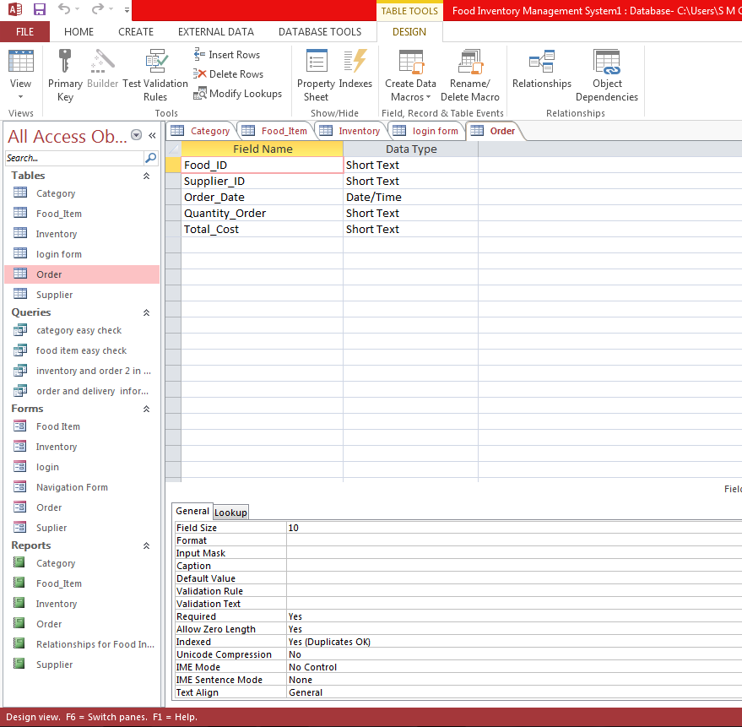

### **Inventory Table**

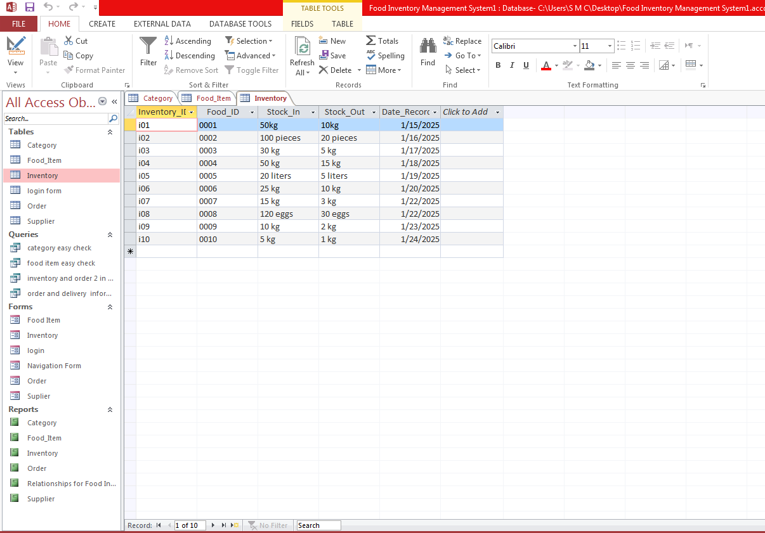

### Design view

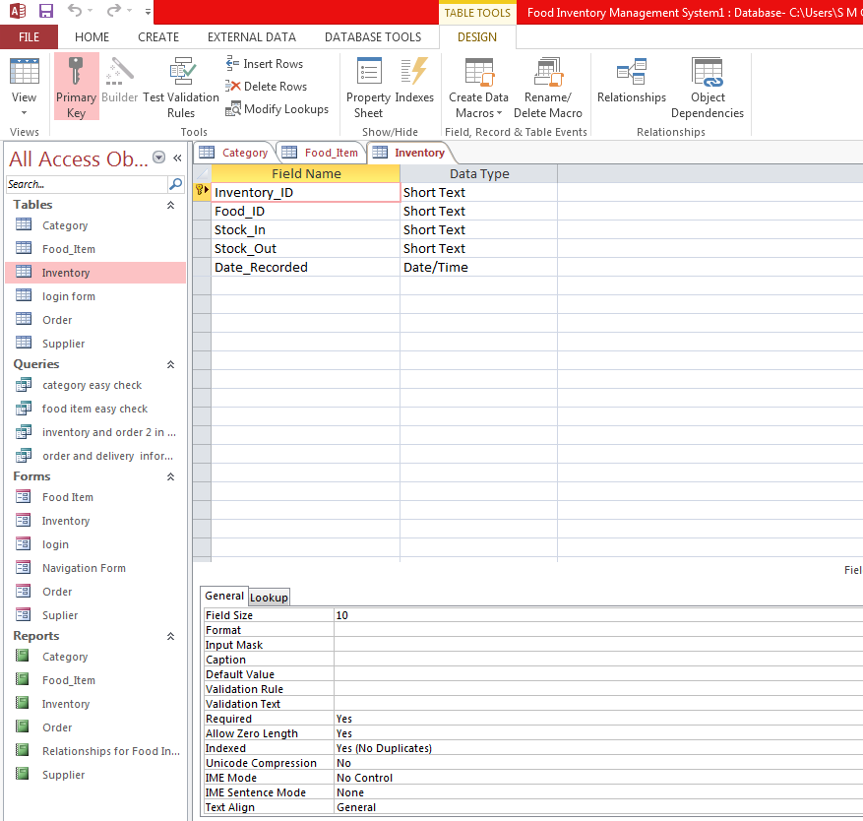

## 5.2. ****Forms****

Forms are used in databases to provide a user-friendly interface for entering, updating, or viewing data. Instead of working directly with tables, users interact with forms. They are commonly used for tasks like adding new suppliers, entering orders, or updating inventory. Forms provide a visual interface that allows users to input data into the database easily.

### Food Item Form:

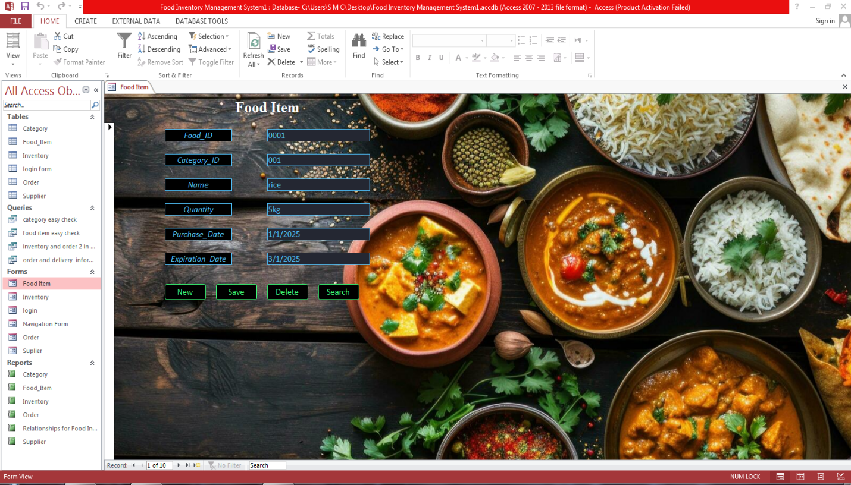

### Design view

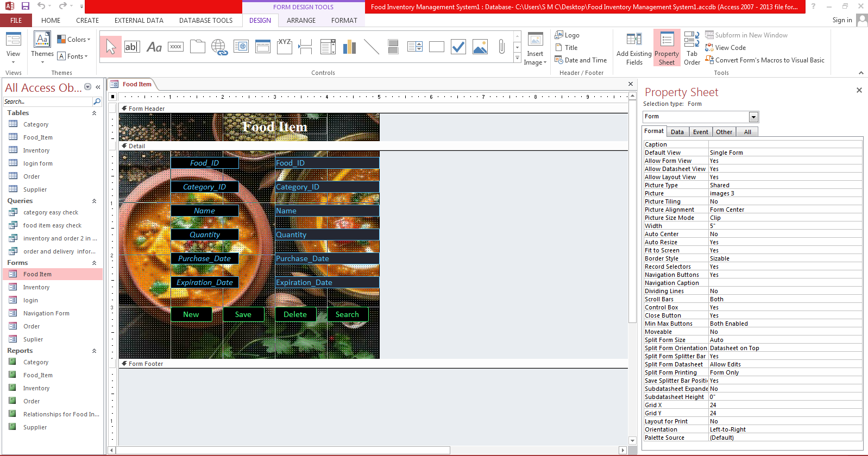

### Inventory Form:

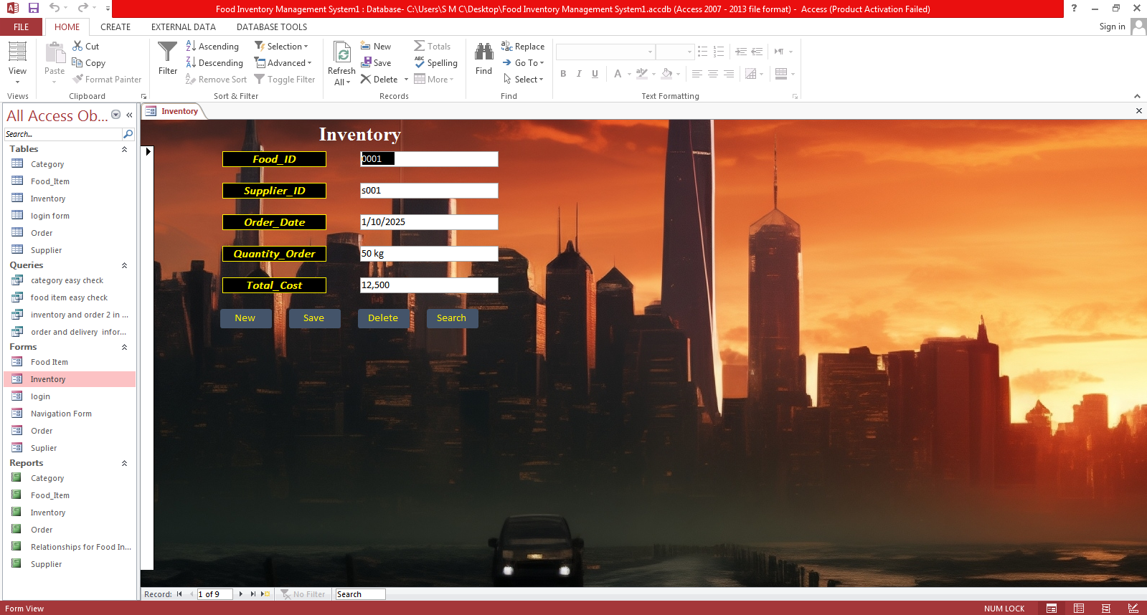

### Design view

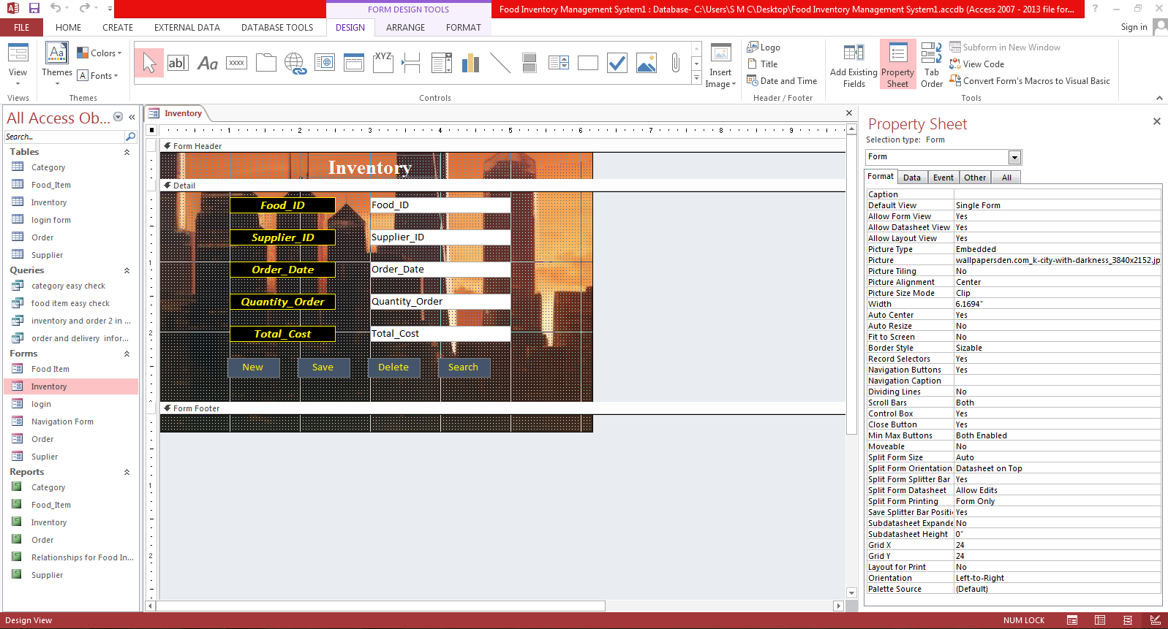

### Login Form:

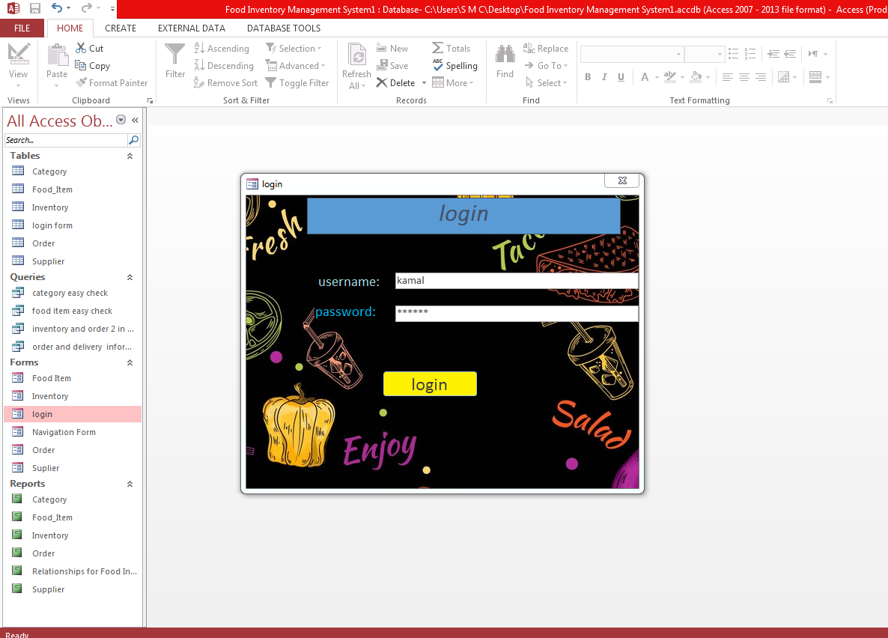

### Design view

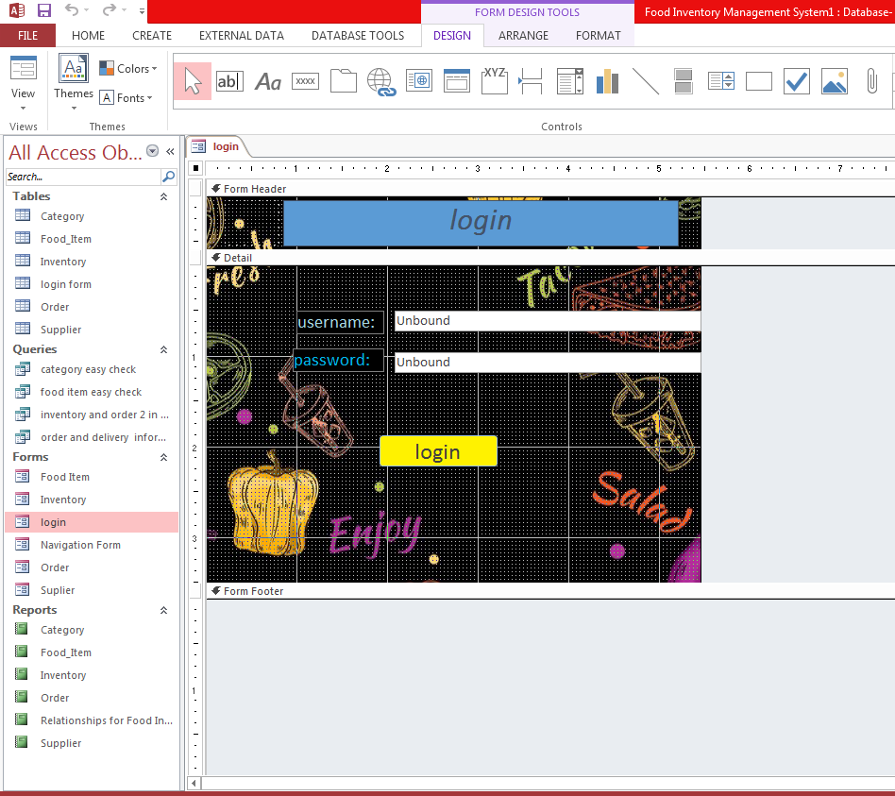

### Login button code

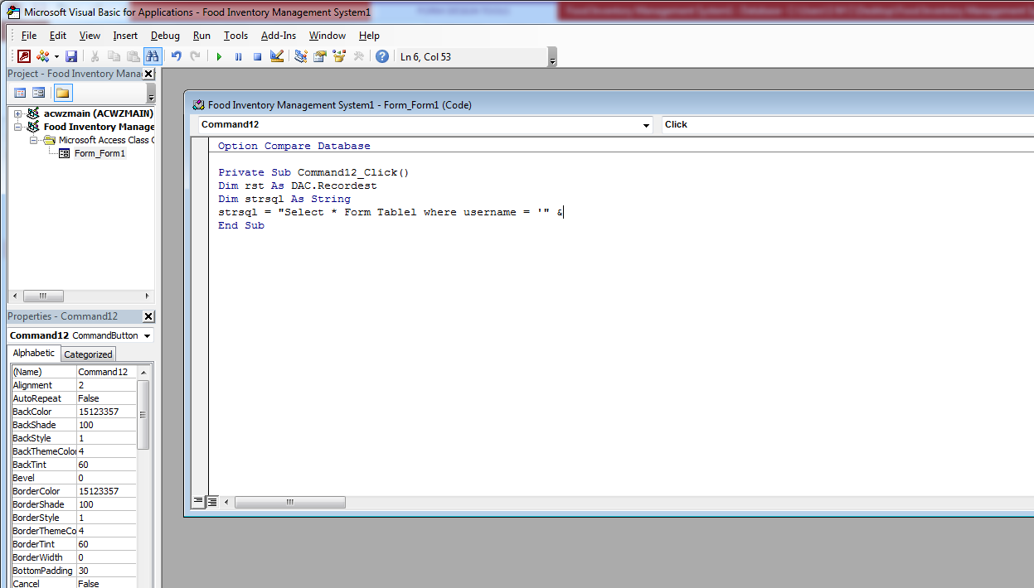

### Navigation Form:

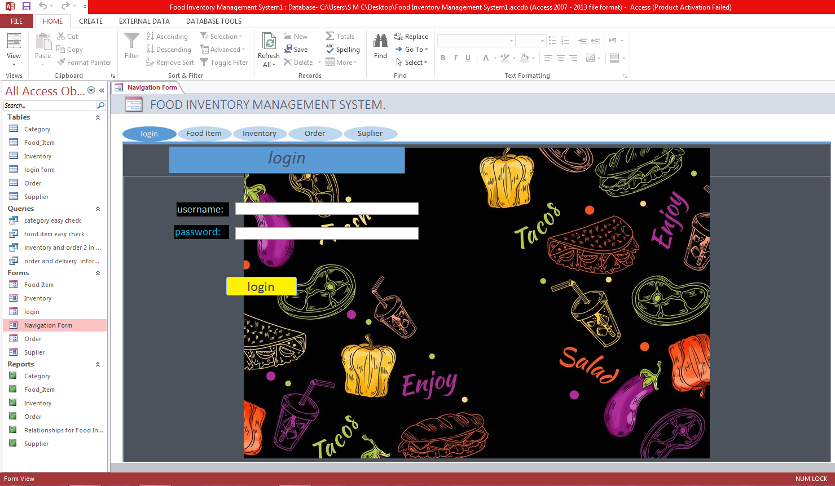

### Design view

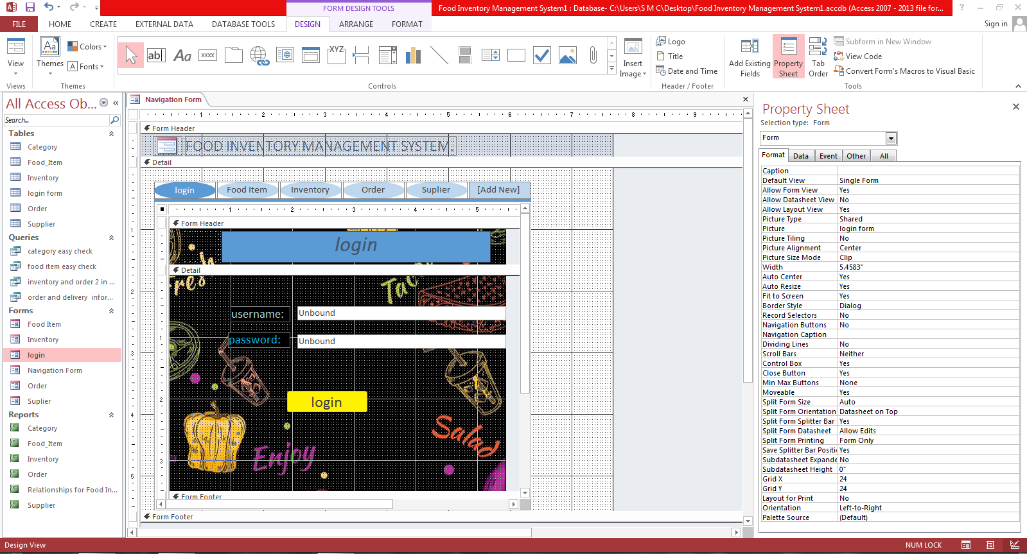

### Order Form:

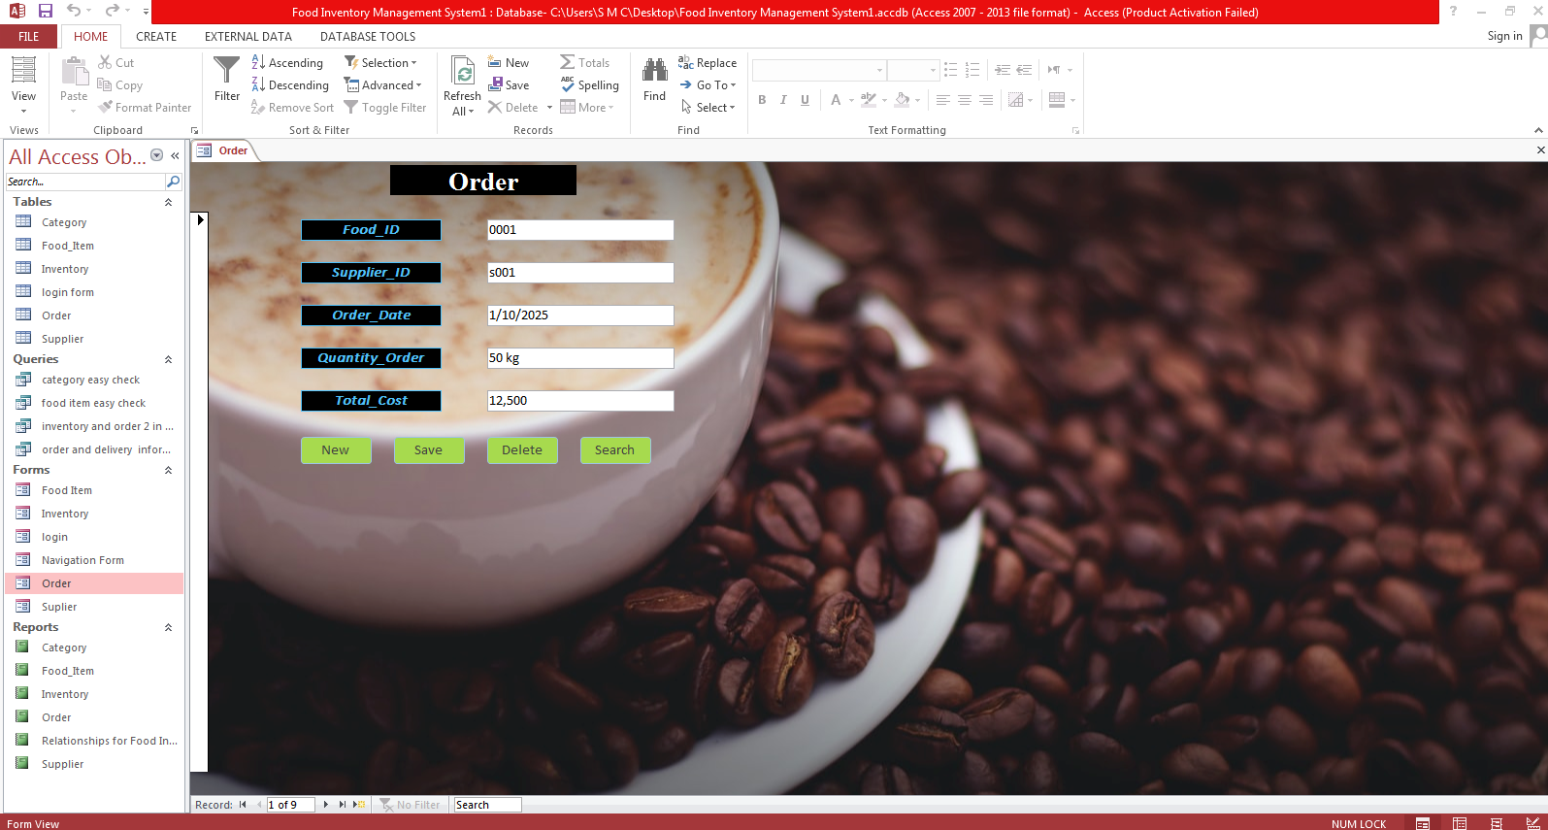

### Design view

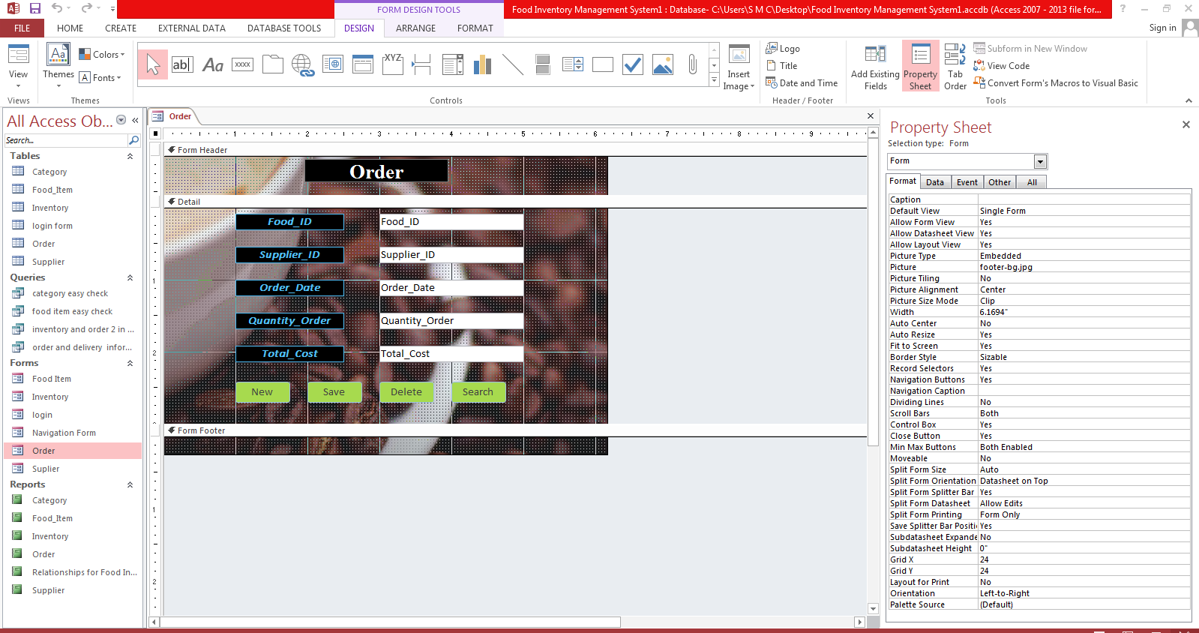

### Supplier form:

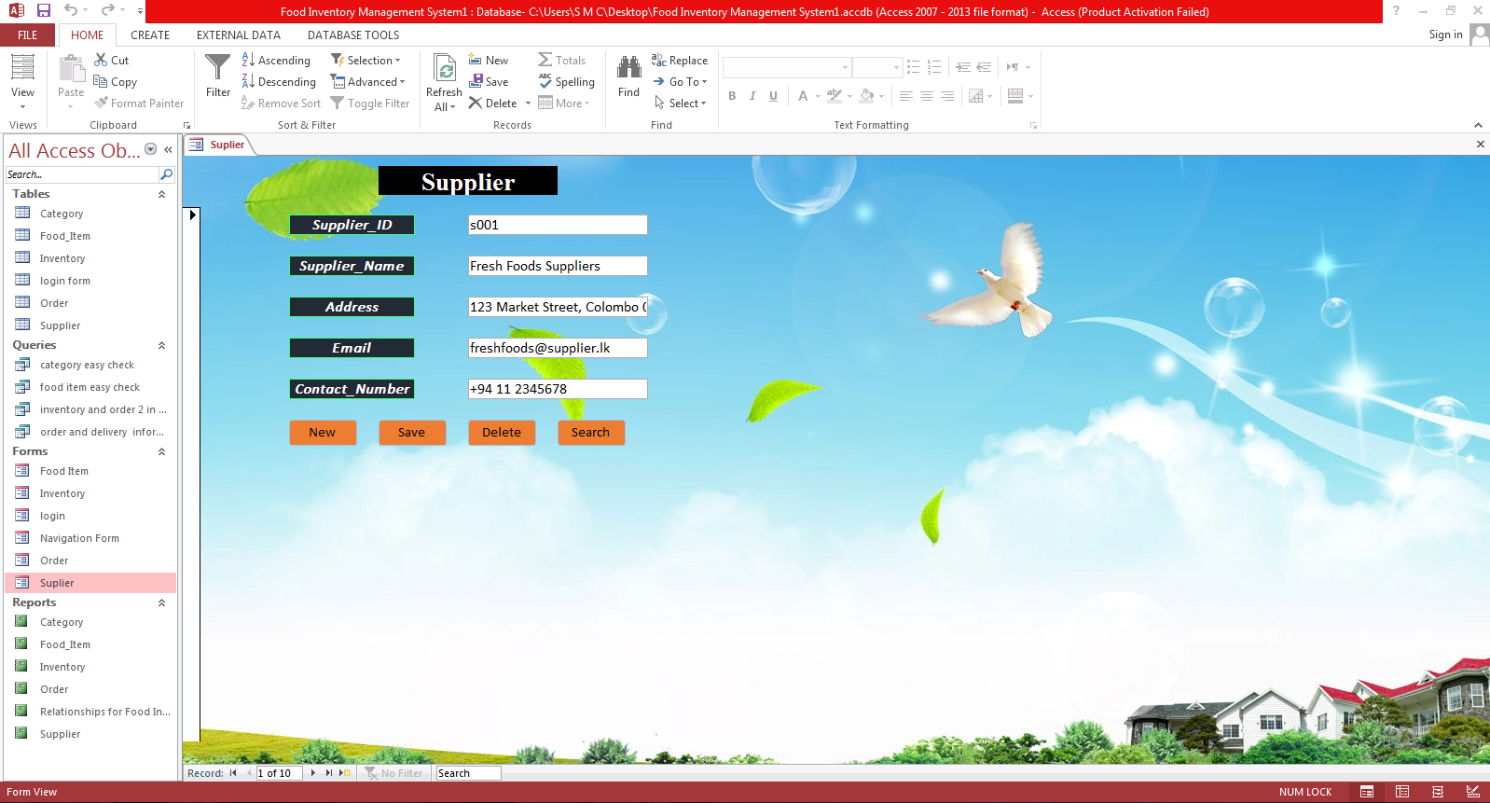

### Design view

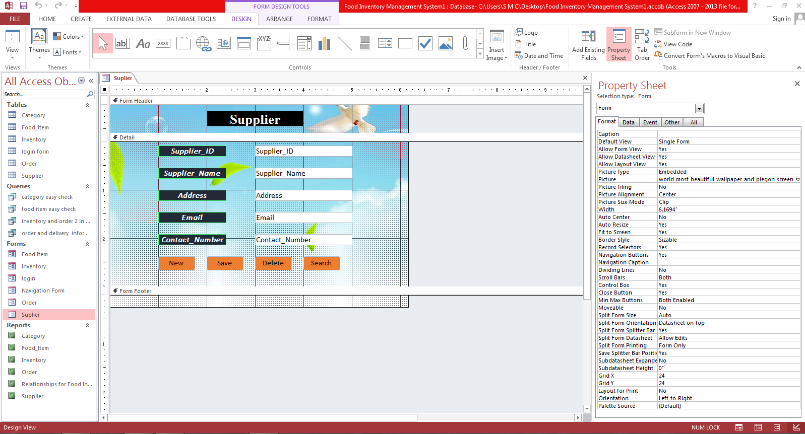

## 5.3. ****Queries****

Queries are used to extract or manipulate data in the database. They are written in a specific query language, like SQL (Structured Query Language). Queries allow users to find, filter, sort, or aggregate data from one or more tables.

### Category easy check

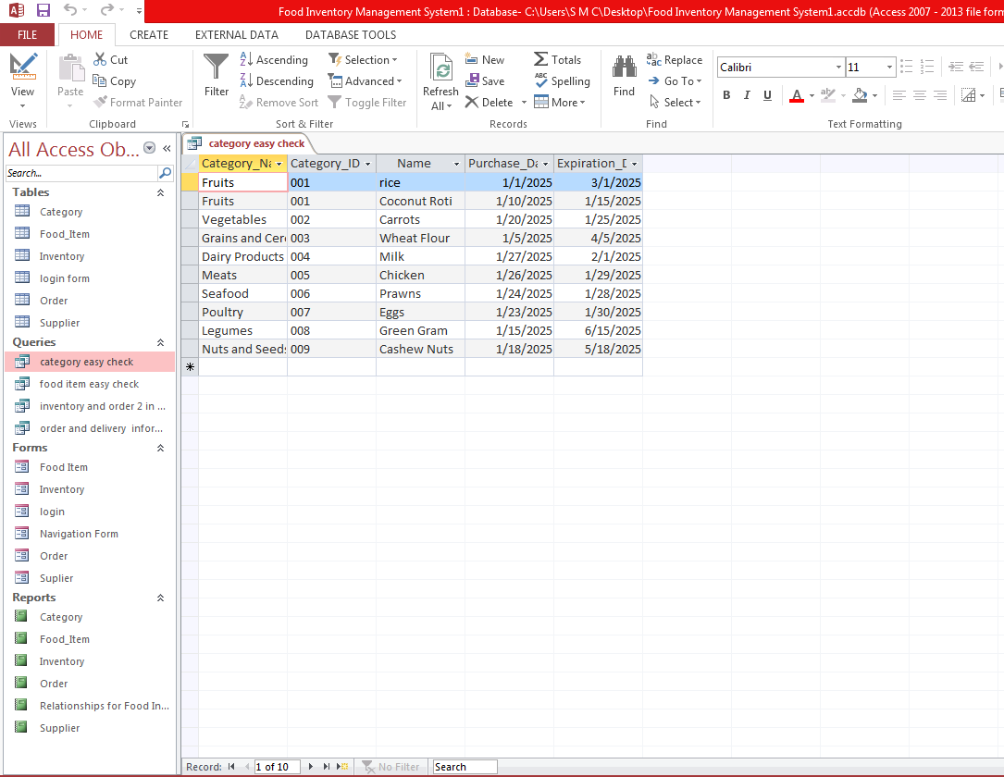

### Design view

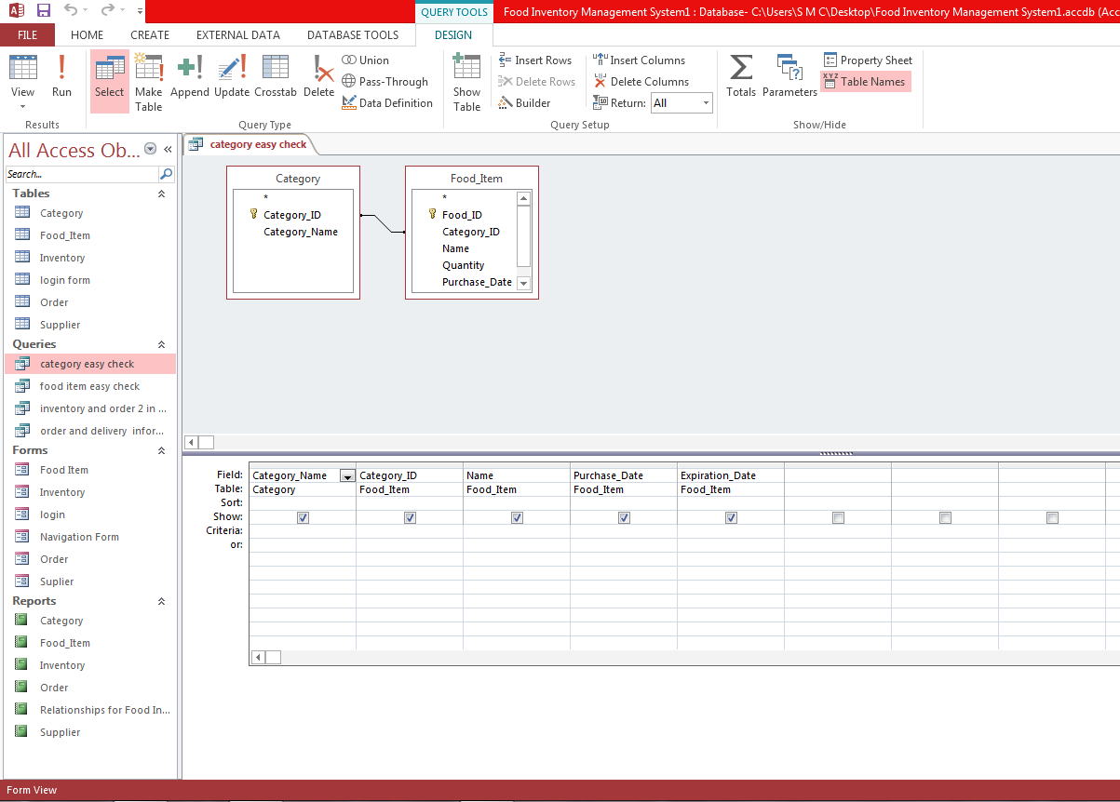

* food item easy check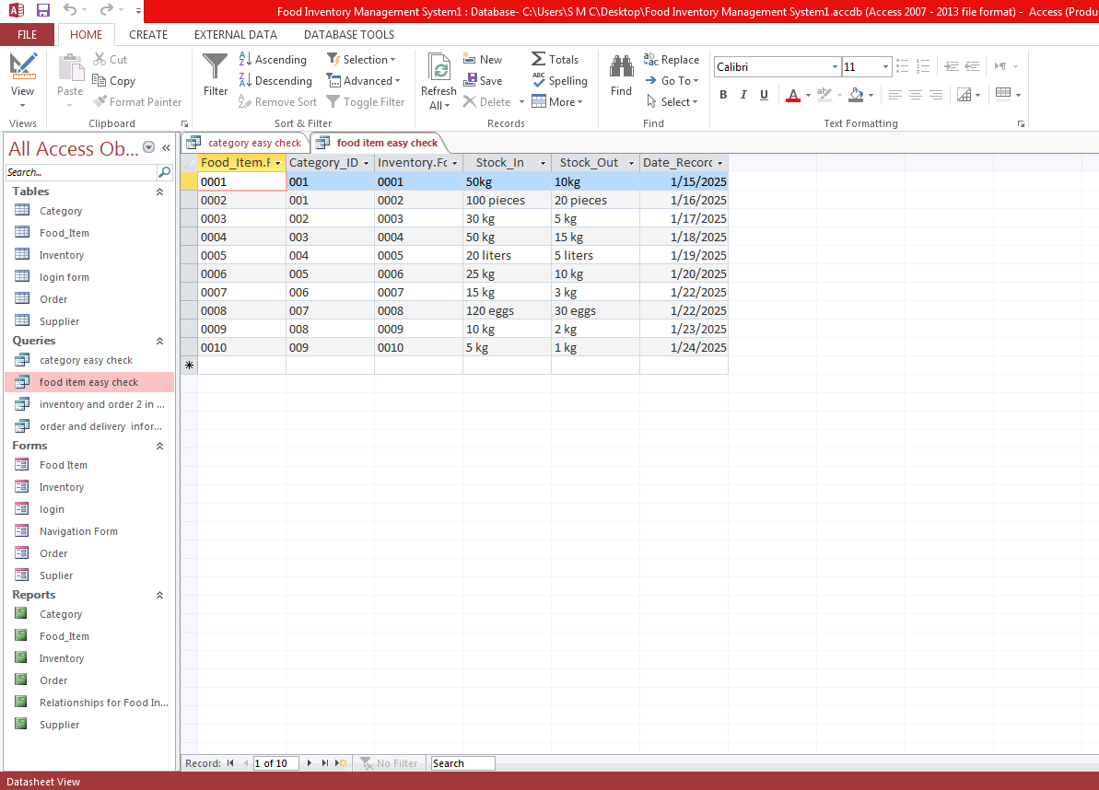

### Design view

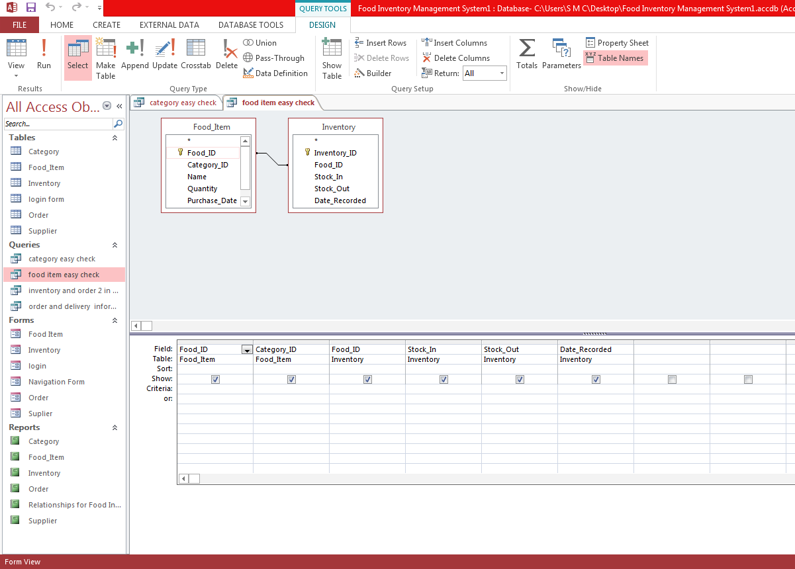

### Inventory and order 2 in one

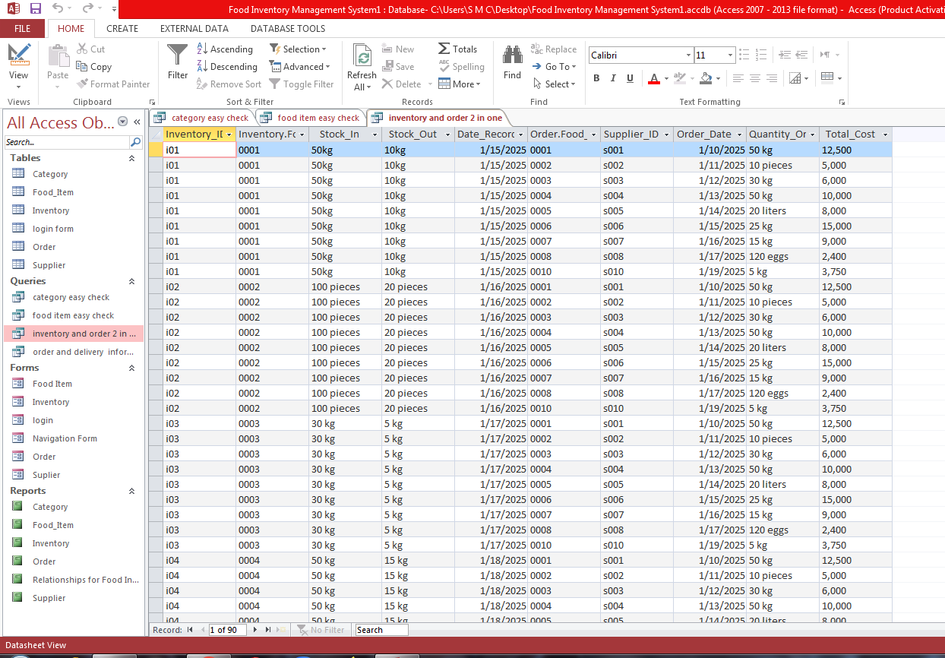

### Design view

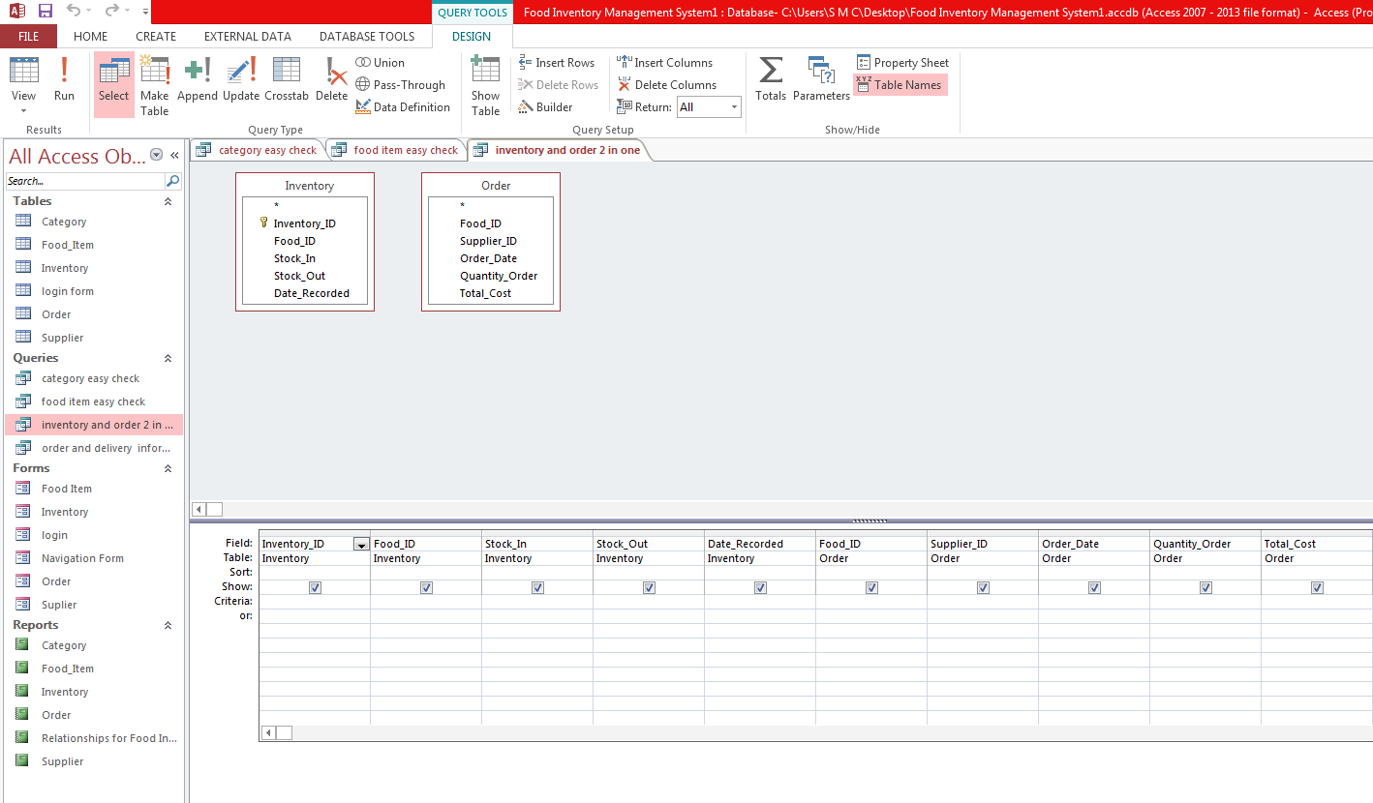

### Order and delivery information’s

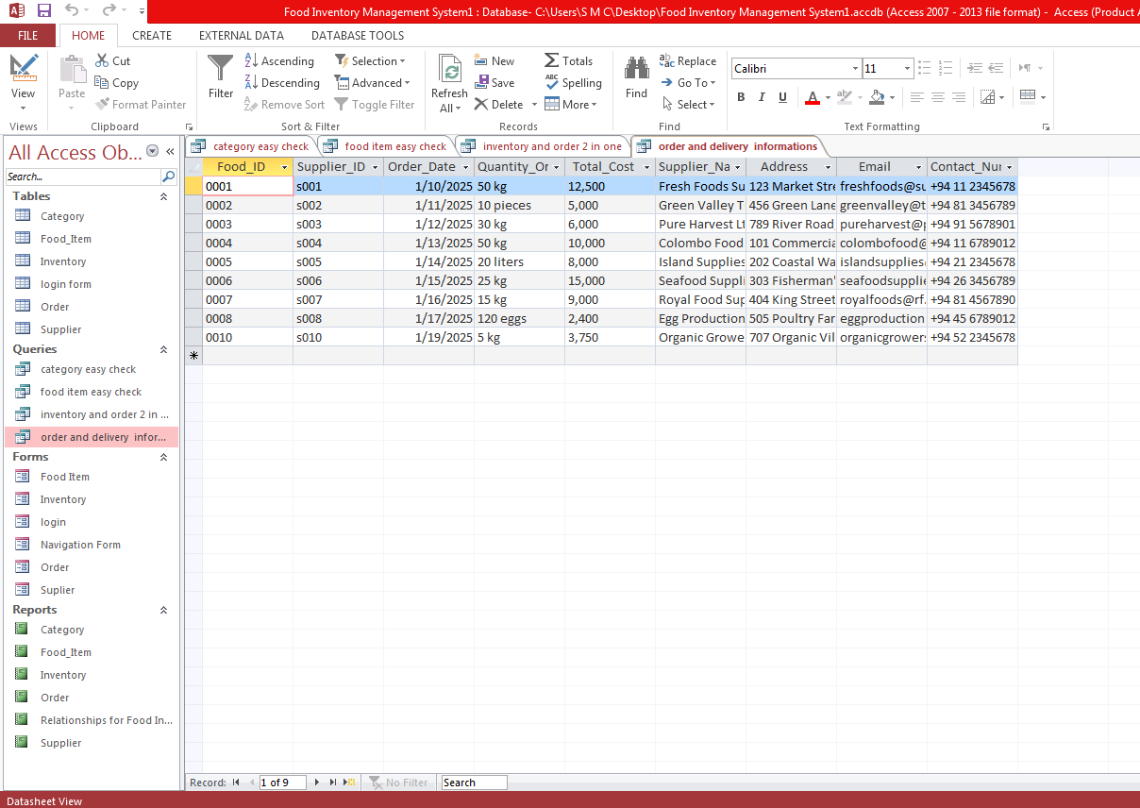

## 5.4. ****Reports****

Reports are used to generate printable, formatted views of the data in the database. They often summarize or aggregate information in a more user-friendly format than raw tables or queries. Reports are especially useful for providing insights, like sales summaries, inventory reports, or supplier performance.

### Category

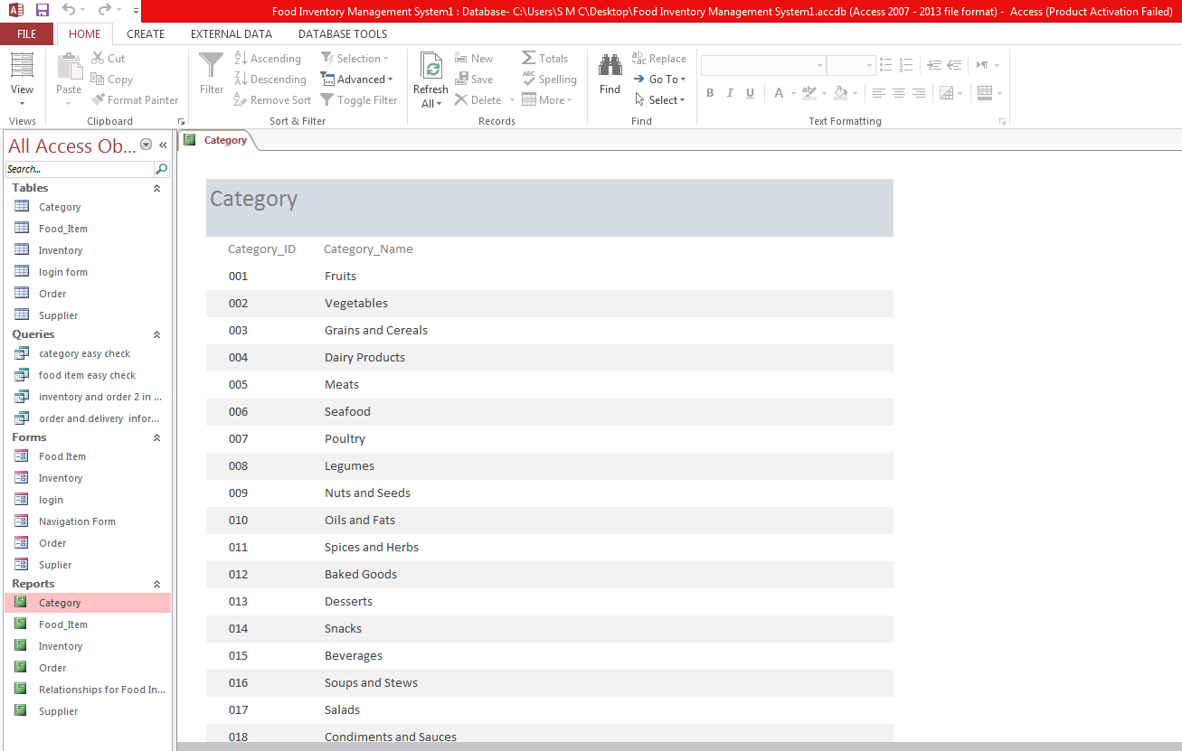

### Food Item

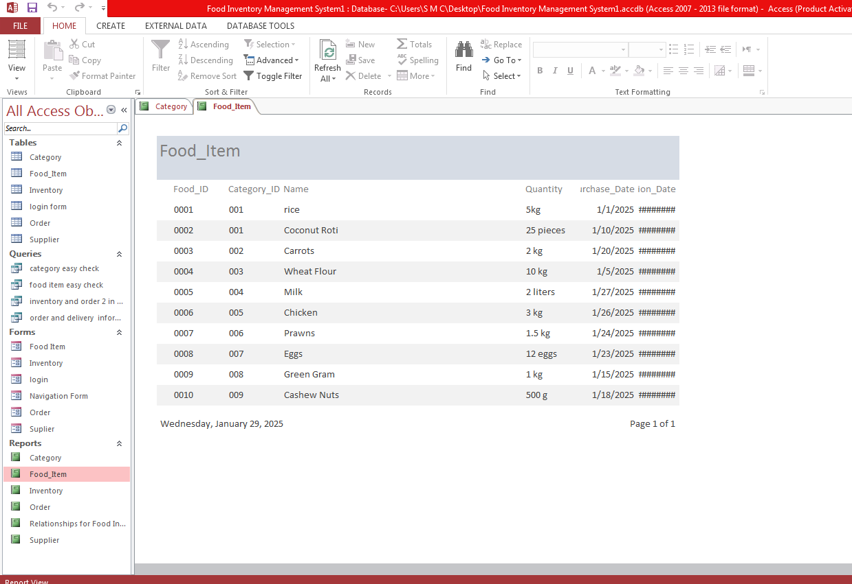

### Inventory

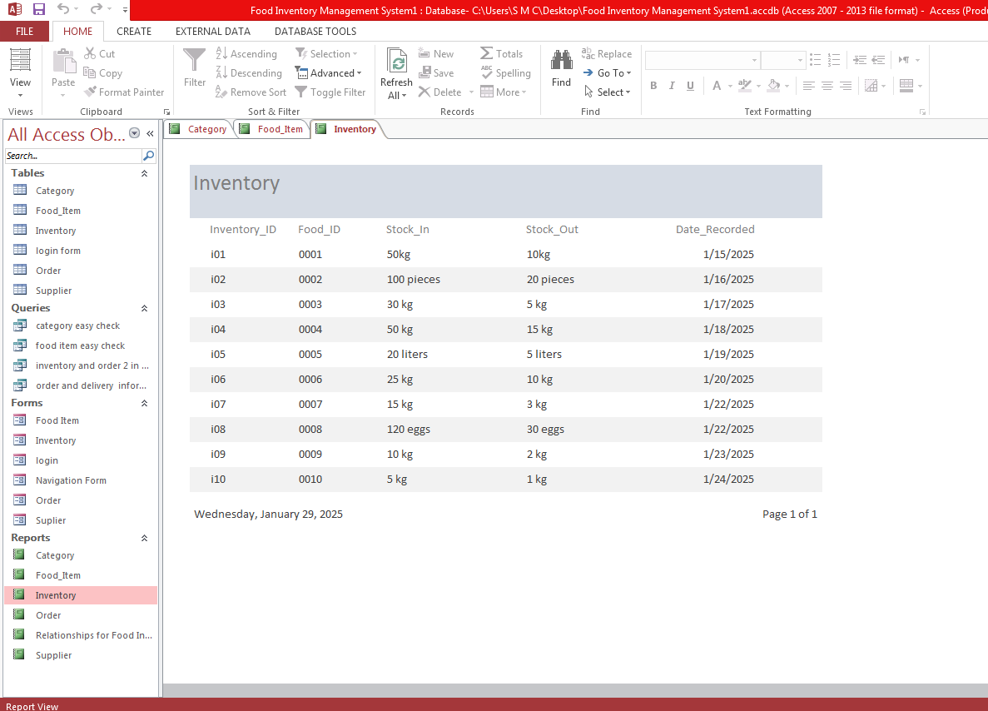

### Order

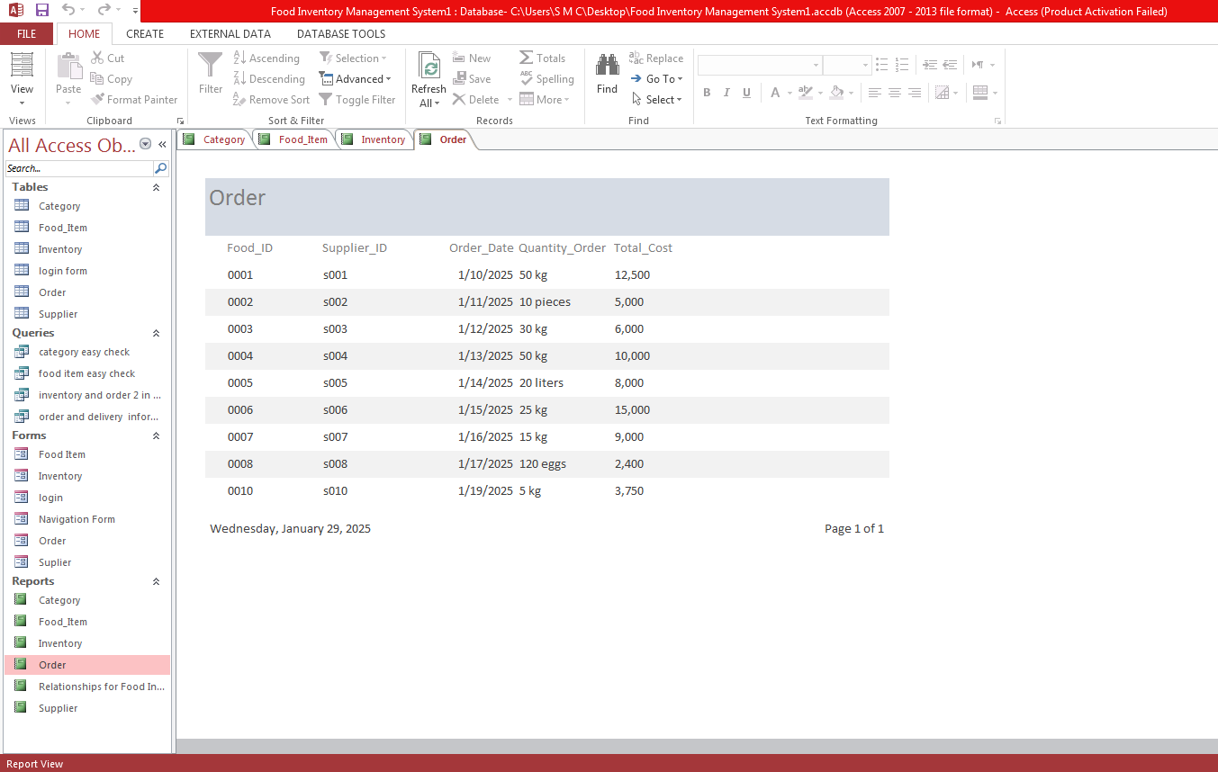

Relationships for Food Inventory Management System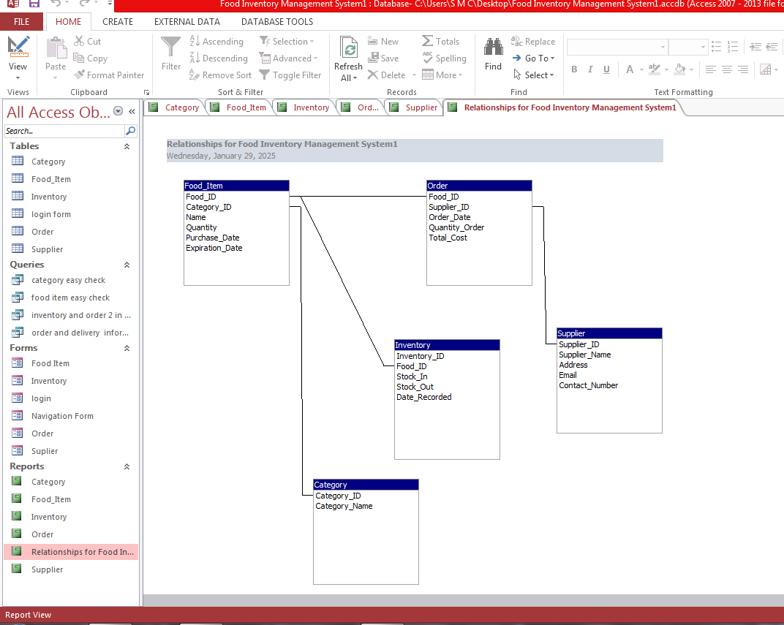

### Supplier

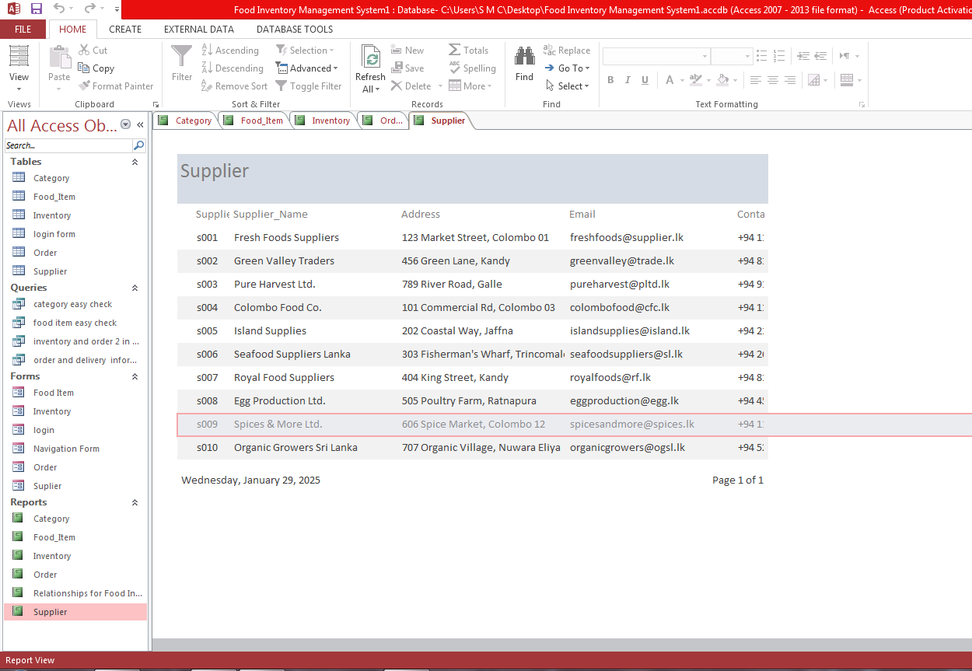

## 5.5. ****Relationships****

Relationships define how different tables in the database are connected to each other. A relationship typically involves a key, such as a primary key in one table and a foreign key in another, linking the tables together.

* **Supplier to Food Items**: There is likely a relationship between the **Supplier Table** and the **Food Items Table**, where each food item is associated with a specific supplier. The **Supplier Table** would have a **Supplier ID** (primary key), and the **Food Items Table** would have a **Supplier ID** as a foreign key.
* **Food Items to Orders**: The **Food Items Table** might be related to the **Order Table** through an intermediary table (such as an order details table) to represent which items were included in a particular order.
* **Orders to Inventory**: There could be a relationship between **Orders** and **Inventory**, where inventory levels are reduced when items are ordered, and stock is updated accordingly.
* By defining relationships between the different tables, the database ensures that the data remains consistent and that it can be easily retrieved and manipulated across different parts of the system.

### 

## Summary of How These Components Work Together:

* **Tables** store the raw data.
* **Forms** provide an easy interface for interacting with the data in tables.
* **Queries** allow for filtering, updating, or manipulating the data stored in tables.
* **Reports** provide a summarized or formatted output for decision-making or record-keeping.
* **Relationships** link Tables together, ensuring data integrity and enabling complex queries and reports that span multiple tables.

# 6) Resources

#### **1. References to Academic Journals/Books**

* Food Supply Chain Challenges in Sri Lanka by Dr. Nimal Perera, Journal of Sri Lankan Logistics, Vol. 8, Issue 2, 2023.
* Optimizing Perishable Food Inventory in Tropical Climates by Dr. K. Senanayake, Colombo Press, 2021.
* Smart Inventory Management for Sri Lankan SMEs by Prof. Malini Gunawardana, 2022.

#### **2. Reports/Statistics**

* 2023 Report on Food Waste in Sri Lankaby the Ministry of Agriculture.
* Perishable Food Inventory Trends in Urban Sri Lanka by Colombo Research Institute, 2022.
* Sri Lanka's Food Supply Chain Review by Lanka Data Insights, 2023.

#### **3. Case Studies**

* **Case Study: Ceylon Grocers**: A grocery chain in Colombo using AI systems to cut expired food by 35%.
* **Case Study: GreenLife Organic Farms**: A local farm integrating solar-powered storage for longer shelf life.

#### **4. Tools/Software**

* **LankaStock**: Inventory management software designed for Sri Lankan food suppliers.
* **PerishPro Lanka**: Tracks food expiry dates and sends alerts for items nearing spoilage.
* **AgriFlow SL**: Helps farmers and retailers manage harvests and stock.

# ****7) Challenges and Solutions****

#### **1. Expiry Dates**

* **Challenge:** Hard to track which food is about to expire.
* **Solution:** Add a column for expiry dates so users can sort and check easily.

#### **2. Large Data**

* **Challenge:** Managing many items takes too much time.
* **Solution:** Allow users to upload a list of items in one go using a CSV file.

#### **3. Low Stock Check**

* **Challenge:** No alerts for low stock means items can run out unexpectedly.
* **Solution:** Add a filter to show items below the minimum quantity.

#### **4. Mistakes in Data Entry**

* **Challenge:** Users might enter wrong information, like letters instead of numbers.
* **Solution:** Add rules to make sure only correct data (like numbers for quantity) is entered.

#### **6. User Difficulty**

* **Challenge:** Some people may not know how to use the system.
* **Solution:** Keep the design simple and include step-by-step instructions.

#### **7. Manual Updates**

* **Challenge:** Users must update stock manually, which can take time.

# ****8) Conclusion****

This food inventory system helps track stock, manage expiry dates, and check for low stock levels. It is easy to use, even without alerts or multi-language options. Users can update inventory quickly and safely, with simple features like batch uploads and checks for errors. The system works on phones, making it convenient for small businesses. Overall, it is a simple and useful tool for managing food inventory.

# 9) Project schedule/plan

|  |  |  |  |  |  |  |  |  |  |  |  |  |  |  |  |  |  |  |  |  |  |  |  |  |
| --- | --- | --- | --- | --- | --- | --- | --- | --- | --- | --- | --- | --- | --- | --- | --- | --- | --- | --- | --- | --- | --- | --- | --- | --- |
|  | **Activities** | **weeks** | | | | | | | | | | | | | | | | | | | | | | |
| **1** | | **2** | **3** | | **4** | **5** | | **6** | **7** | | **8** | **9** | | **10** | **11** | **12** | **13** | | **14** | **15** | |
| **01** | **Design** |  | |  |  | |  |  | |  |  | |  |  | |  |  |  |  | |  |  | |
| **02** | **Visit and collect info:** |  | |  |  | |  |  | |  |  | |  |  | |  |  |  |  | |  |  | |
| **03** | **Arrange data** |  | |  |  | |  |  | |  |  | |  |  | |  |  |  |  | |  |  | |
| **04** | **Design the project** |  | |  |  | |  |  | |  |  | |  |  | |  |  |  |  | |  |  | |
| **05** | **Find errors and fix** |  | |  |  | |  |  | |  |  | |  |  | |  |  |  |  | |  |  | |
| **06** | **Finish the final project** | |  |  |  |  | |  |  | |  |  | |  |  | |  |  | |  |  | |  |

***Table 1Project Schedule***

10) References

classnet. *inventory management*. america, 2020. <<https://assets.ctfassets.net/hfb264dqso7g/3KMzofgMM9PAaDvXHTeLXJ/cf96f49029129793bd82811b43406ac7/inventory-management-pdf.pdf>>.

fishbowl. *what is inventory management?* us:<https://youtu.be/sl5zEPRkp0U>, 2004.

wikipidiya. *inventory*. 2008. <<https://en.wikipedia.org/wiki/Inventory>>.

zebra. *What Is Food Inventory Management?* america, 2018. <[https://www.zebra.com/ap/en/resource-library/faq/what-is-food-inventory-management.html#:~:text=Food%20industry%20inventory%20management%20encompasses,receiving%20and%20storing%20of%20goods](https://www.zebra.com/ap/en/resource-library/faq/what-is-food-inventory-management.html%23:~:text=Food%20industry%20inventory%20management%20encompasses,receiving%20and%20storing%20of%20goods).>.